RM of Torch River No. 488  110 Main Street  Box 40 White Fox, SK S0J 3B0 | 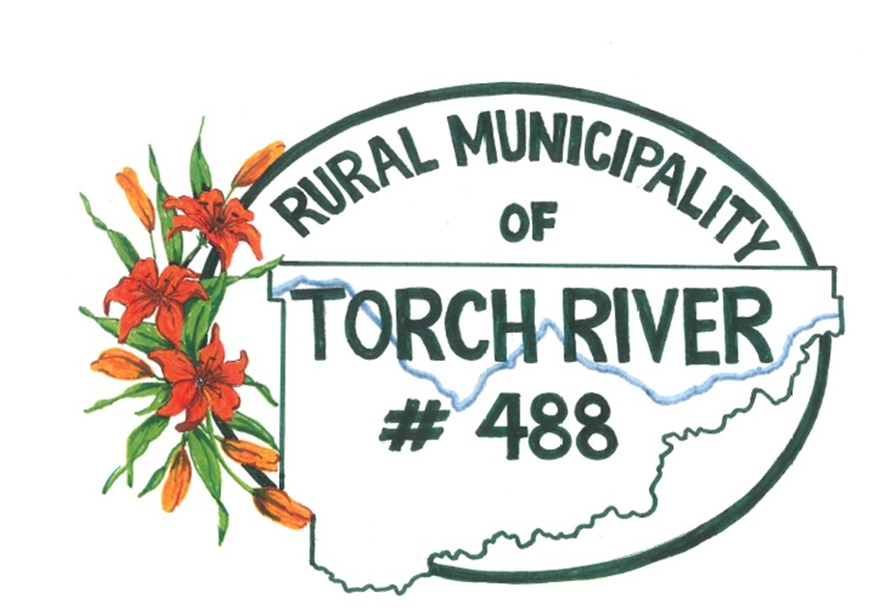
  - Application Form

Committee Members & Board Members
Name: ____________________________________________________________________________
Mailing Address: ____________________________________________________________________
Land Location: _____________________________________________________________________
Phone Number: (Home) ___________________________ (Cell): _____________________________
I am willing and able to attend committee meetings and report to council regularly

I am interested in the following Board(s) & Committee(s)
A.D.D Board

Airport Expansion Study

APAS

Diamond Development Advisory

EDC – Nipawin

EDC – Smeaton

Forest Management Planning Public Advisory Group

Gateway Keewatin Corridor

Library – Choiceland

Library – White Fox

NE Infrastructure Steering Committee

North East Health

Torch River Rail

Twin Lakes Planning District

Agriculture

Financial Planning Committee

Fire Dept – Nipawin
Fire Dept – Choiceland
Fire Dept – Smeaton
Joint Venture
Joint Venture Emergency Management Organization
Gravel Committee
Occupational Health & Safety
Personnel Committee
Recreation & Culture Grant
Road Ban
Treaty Land Entitlement
Wapiti Library

Woodland Caribou Range Planning

